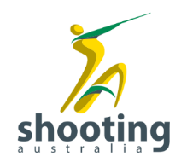
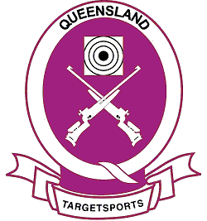
BISC CUP - RIFLE
BRISBANE INTERNATIONAL SHOOTING CENTRE
8 to 11 APRIL 2022

ENTRIES CLOSE 5pm Monday 4 April 2022

PROGRAMME
FRIDAY 8 APRIL | Arrival & Practice 10 & 50m
SATURDAY 9 APRIL | Prep & Sight | Comp Start | Range
10m Air Rifle Men | 08.45 | 09.00 | 10m
10m Air Rifle Women | 08.45 | 09.00 | 10m
 | Report Time
10m Air Rifle Men FINAL | 10.45 | 11.15 | FH
10m Air Rifle Women FINAL | 11.45 | 12.15 | FH
Practice |  | 14.00-16.00 | 50m
SUNDAY 10 APRIL | Prep & Sight | Comp Start | Range
50m Prone Men/Jnr Men | 09.45 | 10.00 | 50m
50m Prone Women/Jnr Women | 11.00 | 11.15 | 50m
Practice 50m |  | 14.00-16.00 | 50m
MONDAY 11 APRIL | Prep & Sight | Comp Start | Range
50m Rifle 3 Positions Men | 08.45 | 09.00 | 50m
50m Rifle 3 Positions Women | 08.45 | 09.00 | 50m
 | Report Time
50m Rifle 3 Positions Men FINAL | 11.30 | 12.00 | FH
50m Rifle 3 Positions Women FINAL | 13.00 | 13.30 | FH

Additional Competition Information:
- Program is subject to change at any time
- Practice is at shooters own cost
- Relevant COVID-19 Safe Guidelines will be applied throughout the competition and on the
Venue
- Athletes will be expected to bring their own food and beverages
- This event is a Shooting Australia 2022 Endorsed Event

