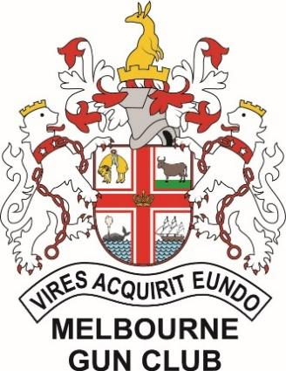
MELBOURNE GUN CLUB
presents
The 2024 YARRA VALLEY
ISSF GRAND PRIX
March 1st to March 3rd, 2024
9:30am Start all days
Friday 1st & Saturday 2nd
125 Tgt ISSF Skeet + Final
Mens 1st, 2nd, 3rd
Womens 1st, 2nd, 3rd
1st AA.A.B.C
Saturday 2nd & Sunday 3rd
125 Tgt ISSF Trap + Final
Mens 1st, 2nd, 3rd
Womens 1st, 2nd, 3rd
1st & 2nd AA.A.B.C
1st, 2nd, 3rd Para Trap (Sponsored by Judith Kent)
Noms - $100 Under 18 - $85
Practice Times
Wednesday 28th of Feb – 12 noon til 6PM
Thursday 29th of Feb – 9:30am til 5PM
Friday 1st of March (Trap only) – 9:30am til 5:30PM
Full Café Menu available Friday, Saturday & Sunday
PRE NOMS TO BE TAKEN VIA MCMS APP FROM JANUARY 24th
ISSF Trap capped at 108 entries, ISSF Skeet capped at 36 entries
Noms close 5pm Monday 26th of February unless fully subscribed earlier
Please notify ASAP if you enter and are unable to attend. Late entries accepted subject to availability.
Draw to be published Wednesday 28th of February
EXCELLENT CASH PRIZES UP FOR GRABS FOR ALL SECTIONS
Ammunition available at club (Bronzewing, Falcon, NSI & Clever)

